**Name: Shasi Venkata Siddarth Paladi**

**700745864**

**Video link: *<https://drive.google.com/drive/u/2/my-drive>***

**Github link: *<https://github.com/SiddarthPaladi/ICP5/tree/main>***

**NEURAL NETWORK AND DEEP LEARNING ASSIGNMENT-5**

**NAÏVE BAYES MODEL**

**Question-1:** Implement Naïve Bayes method using scikit -learn library Use dataset available with name glass Use train test split to create training and testing part Evaluate the model on test part using score and classification_report(y_true, y_pred)

­

**NAÏVE BAYES MODEL**

1: imported pandas library to read the data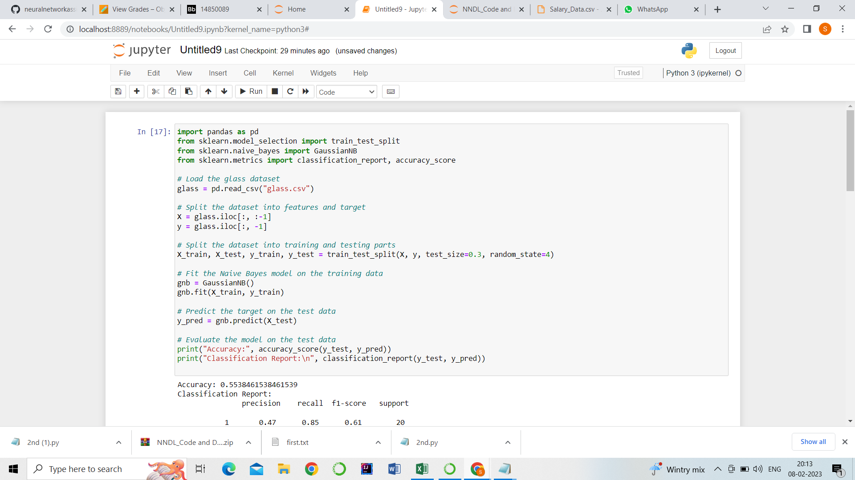

2:From sklearn library I imported train test split

3. There are some classifiers in Naïve Bayes, GuassianNB is one of the classifier.

4. Data is read from glass.csv file and stored in glass.

5. x is input and y is output

6. we used train test split to create training and testing part.

7.After that, we evaluated the model on test part using score card classification report(y_true, y_pred).

**Output: Accuracy is 55%.**

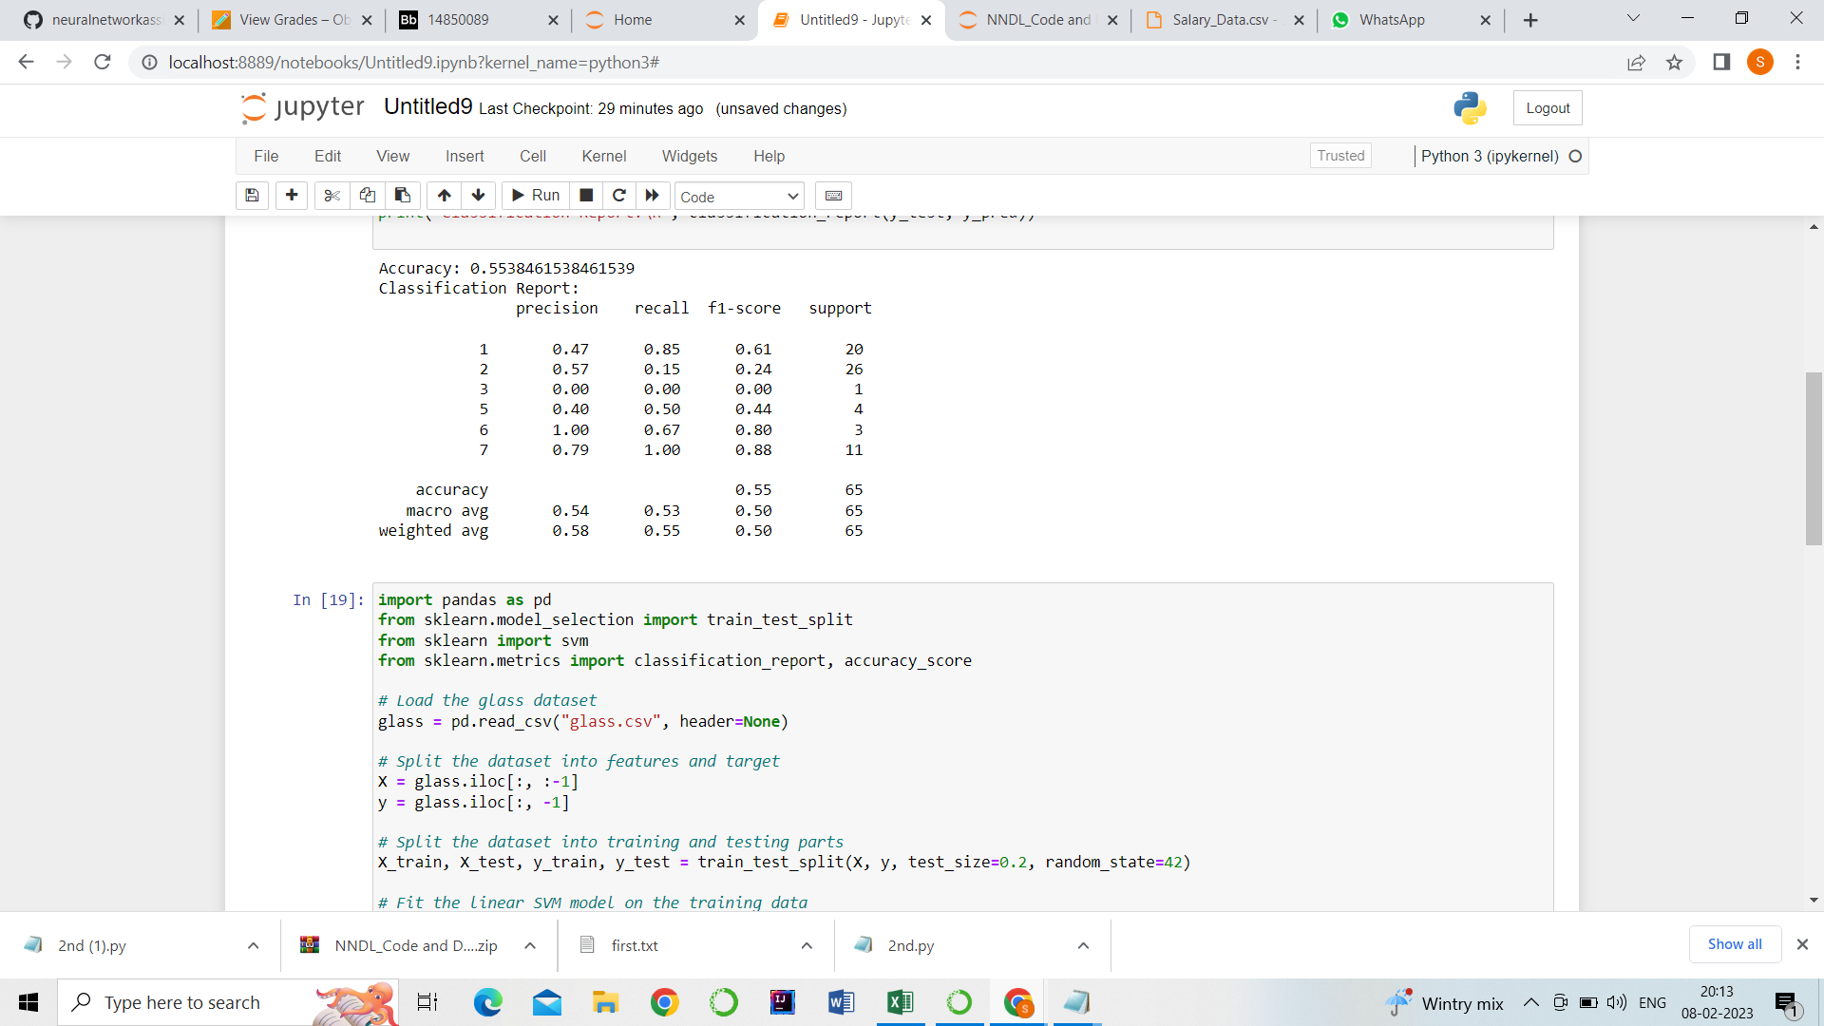

**SVM MODEL**

**Question-2:** Implement linear SVM method using scikit library Use the same dataset above Use train_test_split to create training and testing part Evaluate the model on test part using score and classification_report(y_true, y_pred)

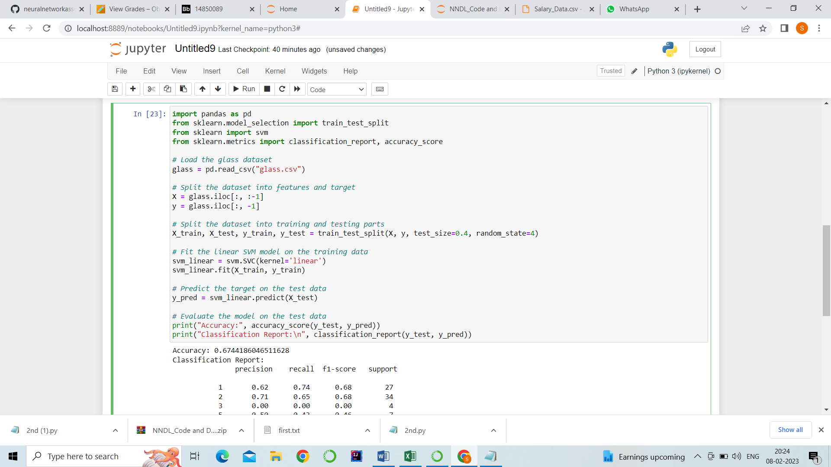

1. Imported pandas library to read the data.
2. From sklearn library I imported train test split
3. There are some classifiers in SVM , SVC is one of the classifier.
4. Data is read from glass.csv file and stored in glass.
5. x is input and y is output
6. we used train test split to create training and testing part.
7. Fit the linear svm model on the training data
8. Predicted the target on the test data.
9. .After that, we evaluated the model on test part using score card classification report(y_true, y_pred).

**Output: Accuracy is 67%**

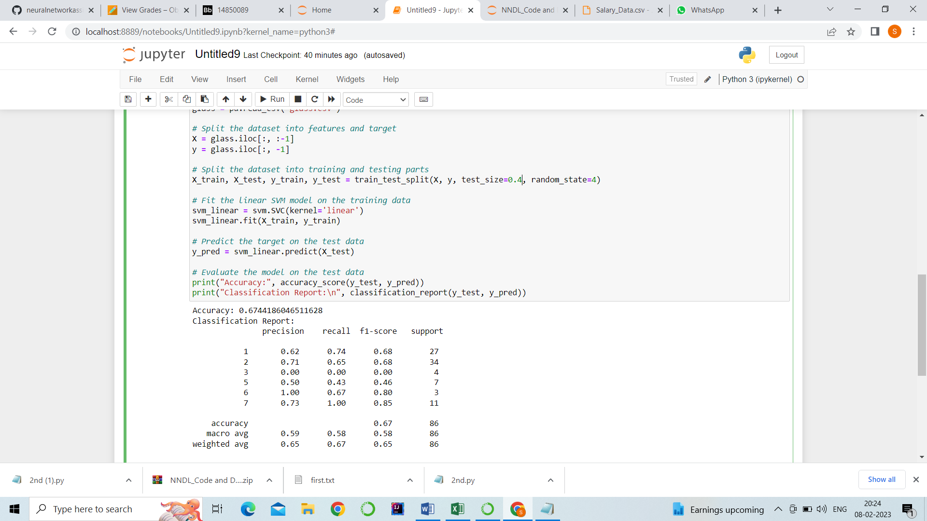

Which algorithm you got better accuracy? Can you justify why?

I got better accuracy in SVM algorithm because SVM applies a geometric interpretation of the data. By default, it is a binary classifier. It maps the data points in space to maximize the distance between two categories.